**Telegram Data Scraping**

1. **Telegram Detailed Privacy Policy for TAPIs(key points).**
   1. **Privacy & Security:** Telegram is a privacy-oriented platform. All client apps must guard their users’ privacy with utmost care and comply with Telegram’s Security Guidelines.
   2. **Data Use:** Telegram only stores the data it needs to function as a secure and feature-rich messaging service. This includes your mobile number and basic account data (which may include profile name, profile picture, and about information) to create a Telegram account.
   3. **API Use:** Before using the Telegram API, please note that all API client libraries are strictly monitored to prevent abuse. If you use the Telegram API for flooding, spamming, faking subscriber and view counters of channels, you will be banned forever.
   4. **Transparency:** You must obtain your own api_id for your application. Your users must be aware of the fact that your app uses the Telegram API and is part of the Telegram ecosystem.
   5. **Advertising & Monetization:** Developers are allowed to monetize their coding efforts through advertising or other legitimate means2. If you decide to monetize your app, you must clearly mention all the methods of monetization that are used in your app in all its app store descriptions.
   6. **Breach of Terms:** If your app violates these terms, Telegram will notify the Telegram account responsible for the app about the breach of terms. If you do not update the app to fix the highlighted issues within 10 days, Telegram will have to discontinue your access to the Telegram API and contact the app stores about the removal of your apps that are using the Telegram API in violation of these terms.
   7. **More Read this:**[Telegram APIs](https://core.telegram.org/#getting-started)
2. **Some of The Thing We Can Do With TAPIs.**
   1. Create Programs with Telegram Messages: The Bot API allows you to easily create programs that use Telegram messages for an interface.
   2. Build Customized Telegram Clients: The Telegram API and TDLib allow you to build your own customized Telegram clients.
   3. Add Telegram Widgets to Your Website: You can add Telegram Widgets to your website1.
   4. Create Animated Stickers or Custom Themes: Designers are welcome to create Animated Stickers or Custom Themes for Telegram.
   5. Build Interactive Games or Provide Personalized News Updates: The Telegram Bot API can be used for a variety of purposes, from video or image manipulation to systems that are responsible for managing notifications.
   6. Host Mini Apps: Telegram bots can host Mini Apps built with JavaScript. This allows for infinitely flexible interfaces that can power everything from online stores to arcade games.
   7. Seamless Authorization and Notifications: Unlike websites, bots support seamless authorization and notifications through Telegram out of the box.
3. **Get Telegram API Key.**
   1. **There are two kind of APIs offer in Telegram  
      First:-** The [**Bot API**](https://core.telegram.org/#bot-api) allows you to easily create programs that use Telegram messages for an interface.  
      **Second:-** The [**Telegram API and TDLib**](https://core.telegram.org/#tdlib--build-your-own-telegram) allow you to build your own customized Telegram clients.   
      You are welcome to use both APIs free of charge.
   2. **So we need Telegram API and TDLib for this Project  
        
      TDLib – build your own Telegram**Even if you're looking for maximum customization, you don't have to create your app from scratch. Try our Telegram Database Library (or simply TDLib), a tool for third-party developers that makes it easy to build fast, secure and feature-rich Telegram apps.  
        
      TDLib takes care of all network implementation details, encryption and local data storage, so that you can dedicate more time to design, responsive interfaces and beautiful animations.  
        
      TDLib supports all Telegram features and makes developing Telegram apps a breeze on any platform. It can be used on Android, iOS, Windows, macOS, Linux and virtually any other system. The library is open source and compatible with virtually any programming language.  
        
      **More Read:** [Telegram Database Library](https://core.telegram.org/tdlib)
   3. **Register for the get telegram APi -** [Authorization (telegram.org)](https://my.telegram.org/auth?to=apps)  
      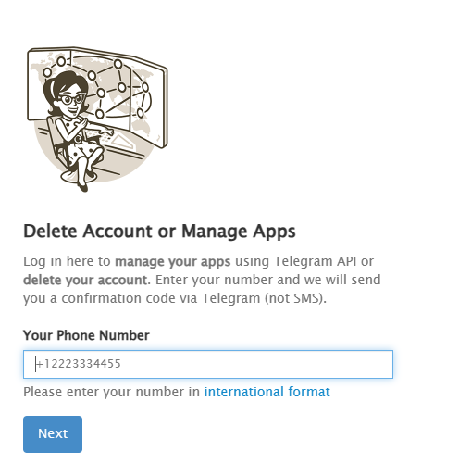 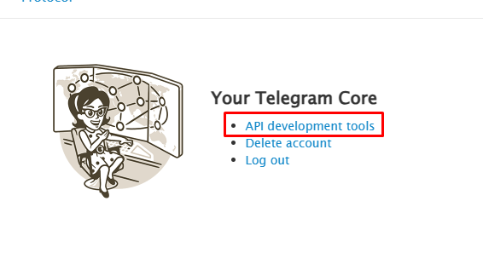
4. **Install Telethon**
   1. Telethon is a Python library, which means you need to download and install Python from https://www.python.org/downloads/ if you haven’t already. Once you have Python installed, upgrade pip and run:  
      *python3 -m pip install --upgrade pip  
      python3 -m pip install --upgrade telethon*
5. **Create Client Object and Login**
6. **Scrape Members from a Group**
7. **Add Members to Your Group**
8. **Store Scraped Members**